CIS 4911 – Senior Project
Tractouch's iBLESS
User Manual

Team Members: Luis Miguel Carrillo
Mentor: Jaime Borras
04/26/2015
COPYRIGHTS AND TRADEMARK INFORMATION

This work is entirely done by Luis Miguel Carrillo unless written otherwise.

View Analytics

Access http://localhost:8080/dashbuilder/login.jsp. Submit login credentials.


Click Analytics. The following screen will be displayed.

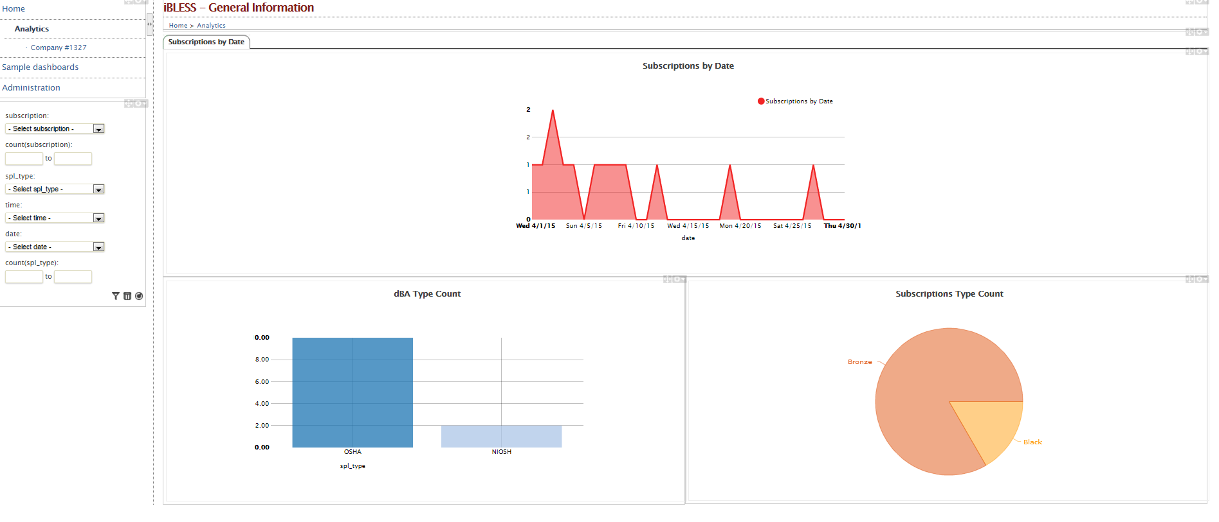

Select company to check. In this example we select company #1327.

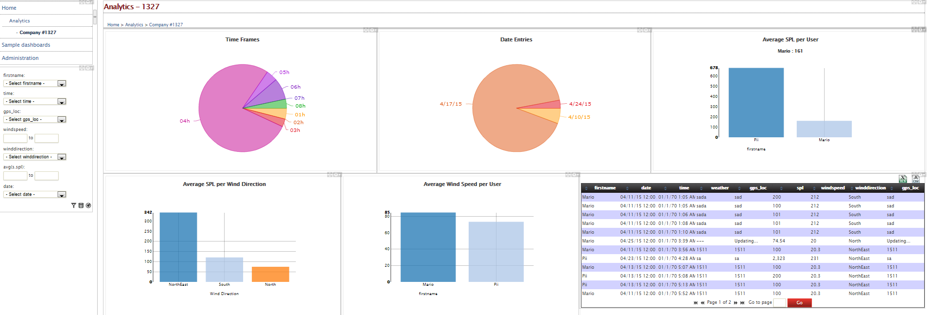
Here, the user can filter the results by click on the respective parts of the graphs or using the filter menu at the left part of the screen. In this tutorial we will select to filter the results by name, by choosing Mario.

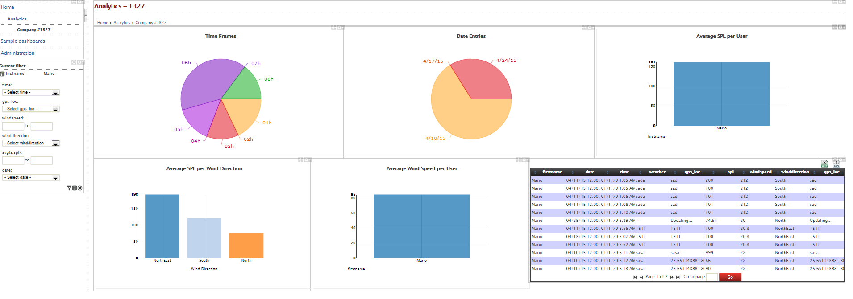
The results can be further narrowed by choosing a new query which is going to be mixed with the previous one. For example, let's select as wind direction north east.

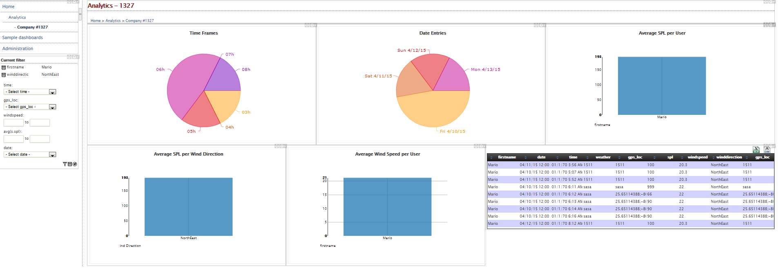
Finally, the queries can be deleted by clicking on the trash icon on the filter menu at the left.

